Study 1 – Experimenter script
Tablet version, with a picture of every screen and the text to say. November 2026.
Study link: https://hannaschleihauf.github.io/Group_Reason_Study_1/

How to use this script
- Each block is one screen of the tablet: a picture of the screen, what to do, and what to say to the child.
- Screens with grey text only are for you. Read them, do what they say, and then tap anywhere on the screen to continue.
- Say the text in quotation marks to the child. Text in [square brackets] is something you do, for example [give the sticker].
- Words in bold change from child to child and from round to round: team names, animals and numbers. The pictures come from one example session. The tablet always shows the right words for the child in front of you: tap the (i) button at the top left to show or hide them.
- Tapped the wrong thing? The ← button at the top left goes back one screen. The answers on that screen are then given again.
- Before you test a child, do one complete practice session with “test run” ticked on the start form. Practice sessions are not counted.

A session at a glance
- Start: the child chooses the Moon team or the Sun team and gets the team’s sticker and hat.
- Stickers and play question: the child shares 5 stickers between a member of each team and says which of the two they would rather play with.
- 4 rounds, each with 10 boxes and two animals: the child says which animal there are more of and how sure they are, watches a video of one team, answers check questions, and then answers again. Round 1 starts with practice on the scale.
- End: the child opens the boxes on the tablet (the child was always right) and chooses a sticker.

1. Start

Start form
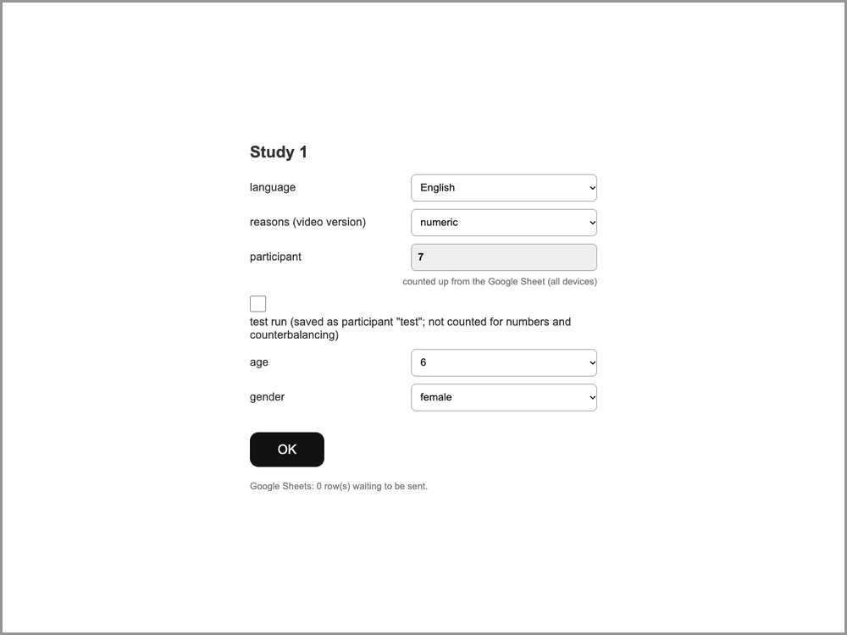 | What to do  Open the study link on the iPad. Choose the language, the video version (“reasons”: numeric, unless your supervisor tells you otherwise), and the child’s age and gender. The participant number is filled in automatically. For a practice session, tick “test run”. Then tap OK.

Welcome and team choice
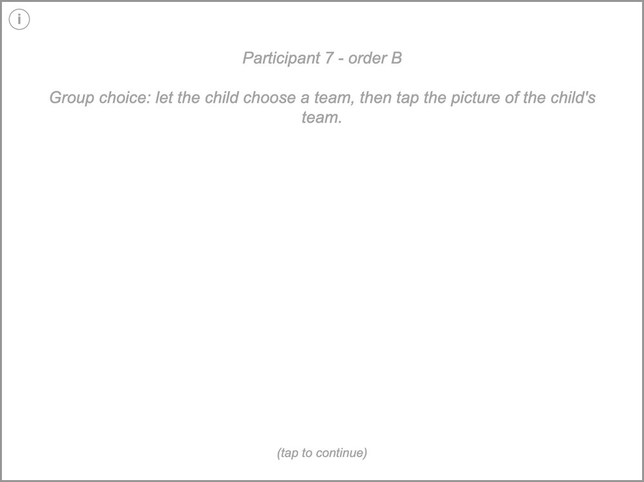 | What to do  Participant 7 - order B  Group choice: let the child choose a team, then tap the picture of the child's team.  What to say  "The game we will play has two teams, the Moon team and the Sun team." [show the team pictures]  "What team do you want to be on today?"

The child chooses a team
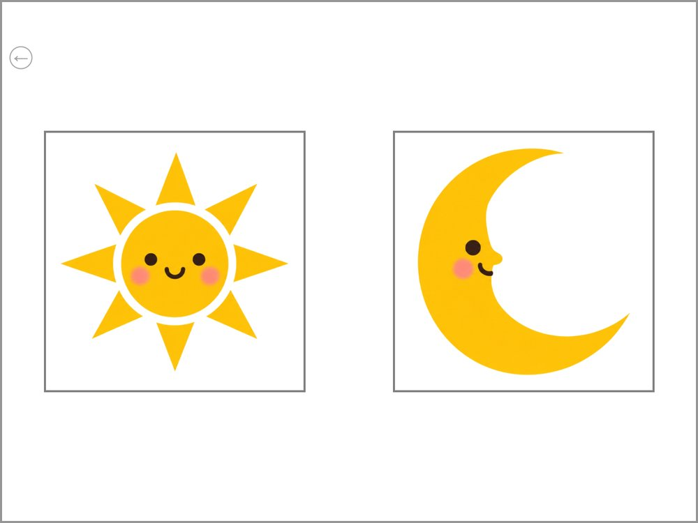 | What to do  The child chooses a team. Tap the picture of the team the child picks.

The two teams
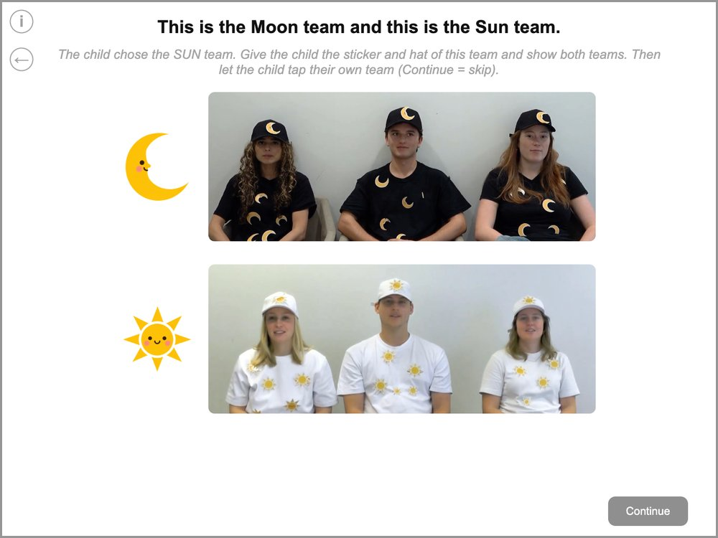 | What to do  The child chose the SUN team. Give the child the sticker and hat of this team and show both teams. Then let the child tap their own team (Continue = skip).  What to say  "Okay! So I have a couple of things for you. First, I have a special Sun team sticker for you." [give the sticker]  "I also have a special Sun team hat for you." [give the hat]  "Great, now you are part of the Sun team!"  [point to the Sun team] "Here are some people who play on your team, the Sun team."  [point to the Moon team] "And here are some people who play on the other team, the Moon team."  "Can you show me your team? Tap on your team!"

2. Stickers and play question

Sticker task: introduction
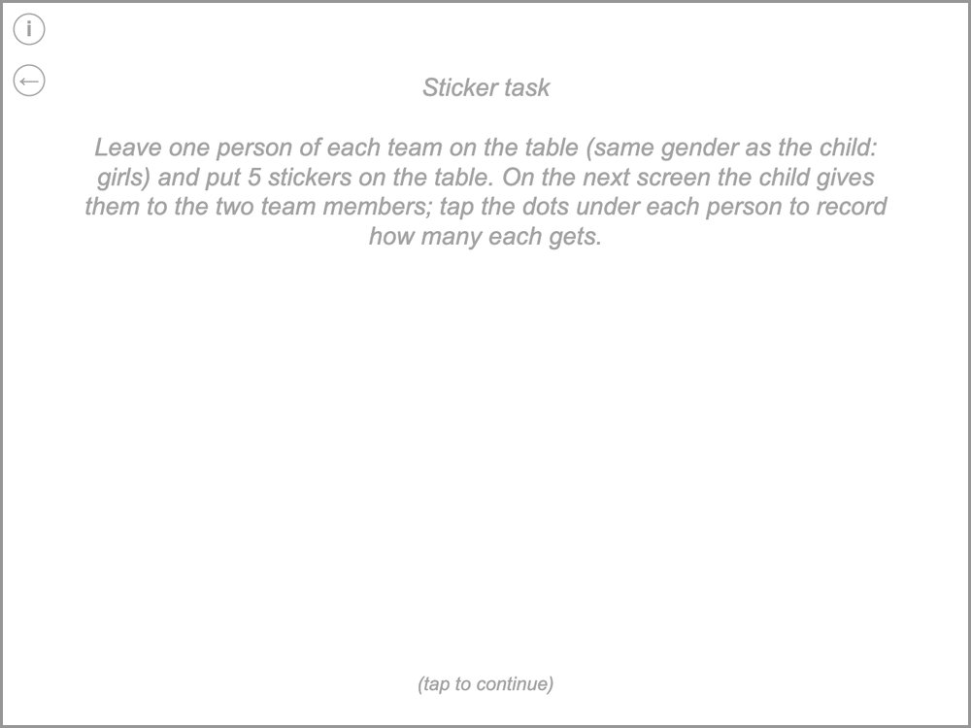 | What to do  Sticker task  Leave one person of each team on the table (same gender as the child: girls) and put 5 stickers on the table. On the next screen the child gives them to the two team members; tap the dots under each person to record how many each gets.  What to say  "Now I will ask you some questions about the two teams. Let's move these people out of the way." [leave one person of each team]  "Now I have some stickers here, let's see how many I have. I have 1, 2, 3, 4, 5 stickers. And now you can tell me how many stickers to give each of these two girls."  [next screen, point to each person]  "So out of these 5 stickers, how many stickers should I give to this girl from your team?"  "Okay, and how many stickers should I give to this girl from the other team?"  [move the stickers out of sight]

Sticker task
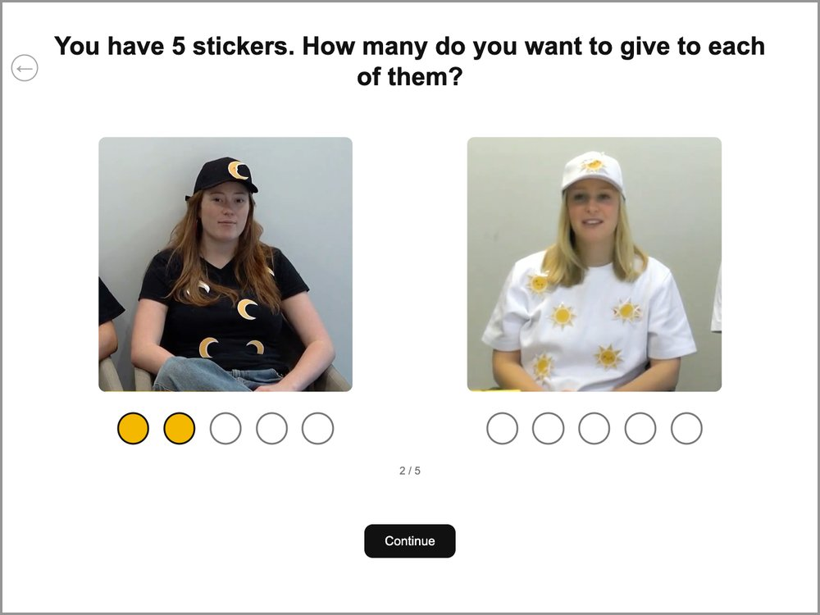 | What to do  The child gives the 5 stickers to the two people. Tap the dots under each person to record how many stickers that person gets. Then tap “Continue”.

Play question
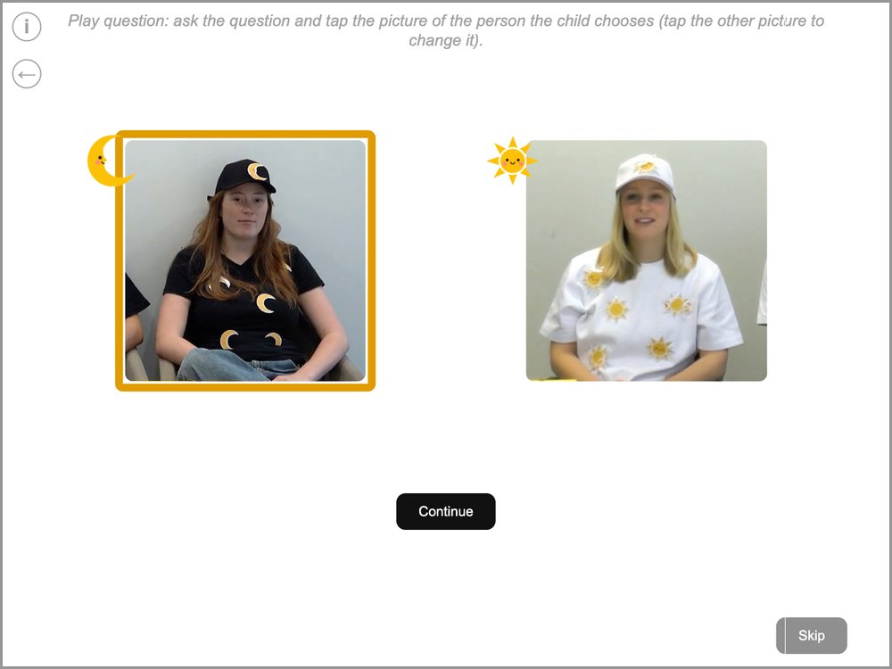 | What to do  Play question: ask the question and tap the picture of the person the child chooses (tap the other picture to change it).  Tap the picture of the person the child points to; a frame shows the choice. To change it, tap the other picture. Then “Continue”. If the child does not choose, tap “Skip”.  What to say  [point to this girl from the other team, then to this girl from your team] "Who would you rather play with: this girl from the other team or this girl from your team?" [let the child point]  [move the photos out of sight] "Later we'll hear from these two teams about the game we will play."

3. Round 1

Round 1: introducing the game
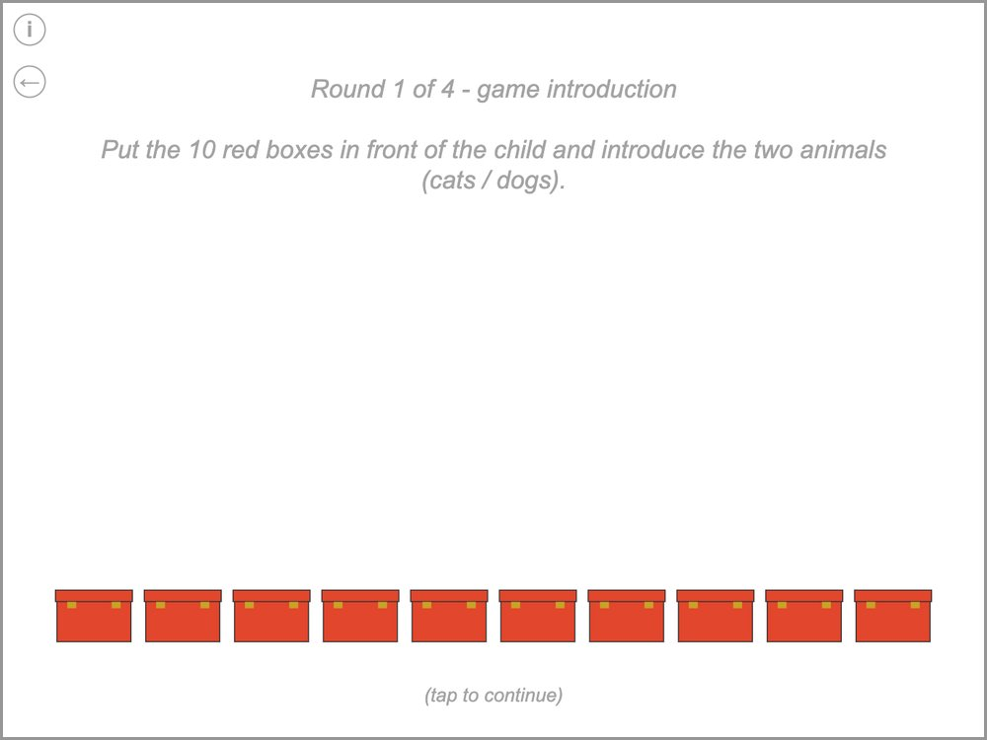 | What to do  Round 1 of 4 - game introduction  Put the 10 red boxes in front of the child and introduce the two animals (cats / dogs).  What to say  "Now we can play the game! The game today involves a zoo. See, here is the zoo! Many animals are part of the zoo, including some cats [hold up the cat] and dogs [hold up the dog]." [let the child name both animals]  "Your job will be to figure out whether there are more cats or more dogs in the boxes. Each one of these boxes has an animal in it, either a cat or a dog. I don't know whether there are more cats or more dogs in the boxes."

Scale practice: show how it works
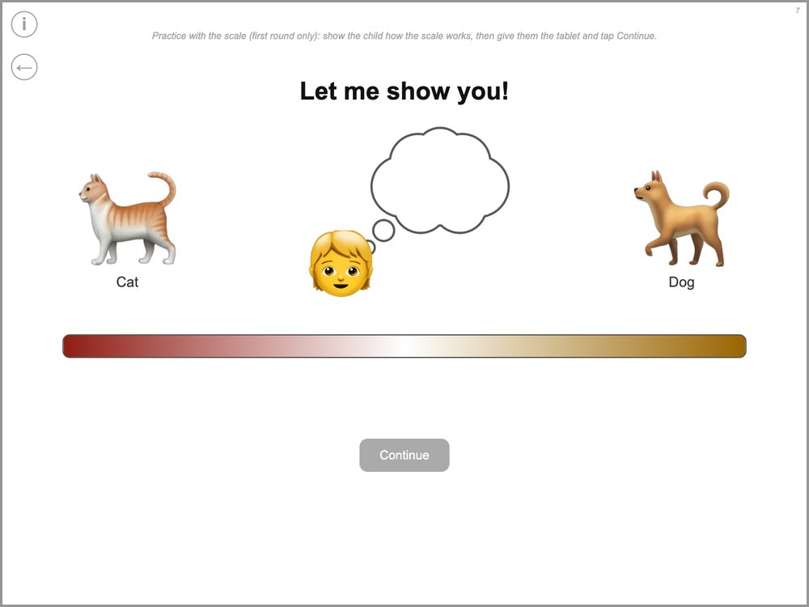 | What to do  Practice with the scale (first round only): show the child how the scale works, then give them the tablet and tap Continue.  What to say  "Later, I will ask you what you think about the boxes, and we'll use this picture for you to tell me." [move the marker yourself]  "If you really think there are more cats, you can place your marker here [far cat side]. If you kind of think there are more cats, somewhere in here [middle of the cat side]." [the same for the dogs]  "And if you don't know, you can place your marker here." [the middle, where the ? appears]

Scale practice 1 of 5
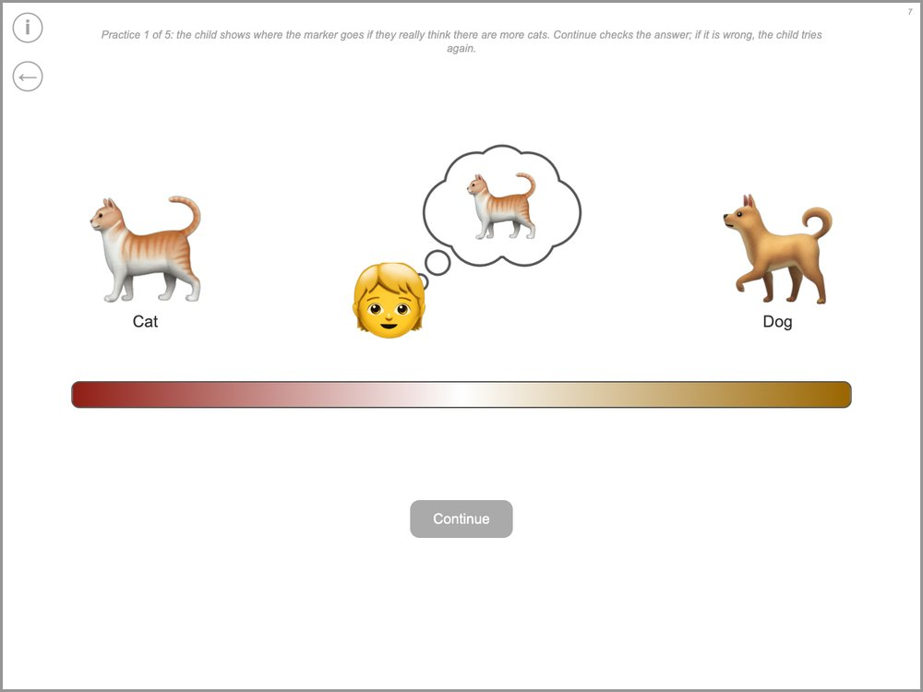 | What to do  Practice 1 of 5: the child shows where the marker goes if they really think there are more cats. Continue checks the answer; if it is wrong, the child tries again.  What to say  "Okay, so later when I ask you, if you really thought there were more cats, where would you place your marker?"

Scale practice 2 of 5
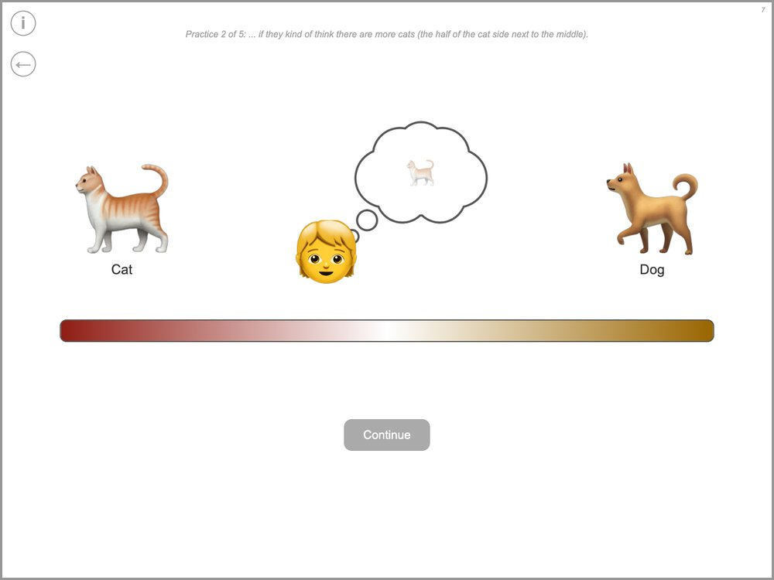 | What to do  Practice 2 of 5: ... if they kind of think there are more cats (the half of the cat side next to the middle).  What to say  "Good, and if you kind of thought there were more cats, where would you place your marker?"

Scale practice 3 of 5
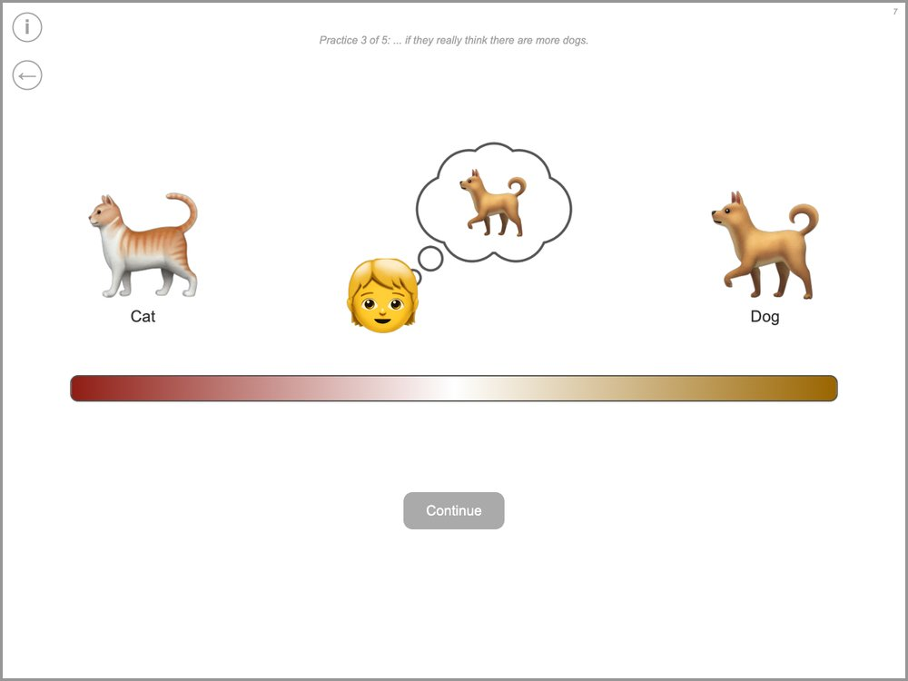 | What to do  Practice 3 of 5: ... if they really think there are more dogs.  What to say  "Good, and if you really thought there were more dogs, where would you place your marker?"

Scale practice 4 of 5
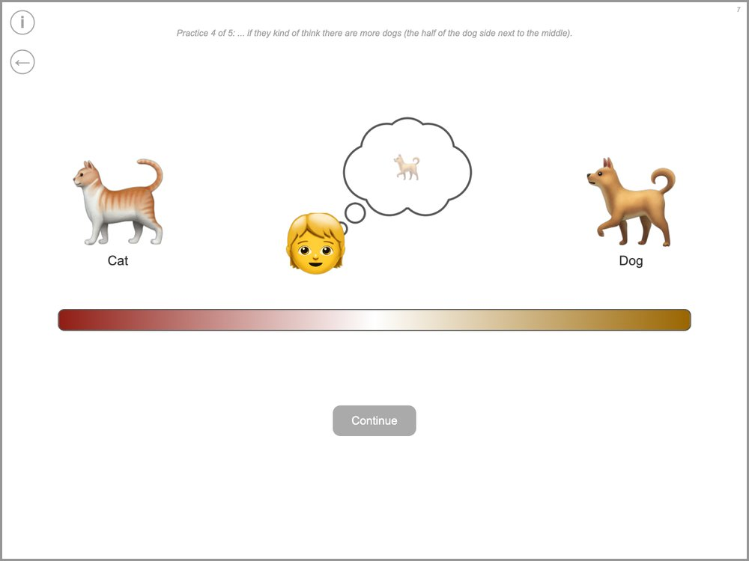 | What to do  Practice 4 of 5: ... if they kind of think there are more dogs (the half of the dog side next to the middle).  What to say  "Good, and if you kind of thought there were more dogs, where would you place your marker?"

Scale practice 5 of 5
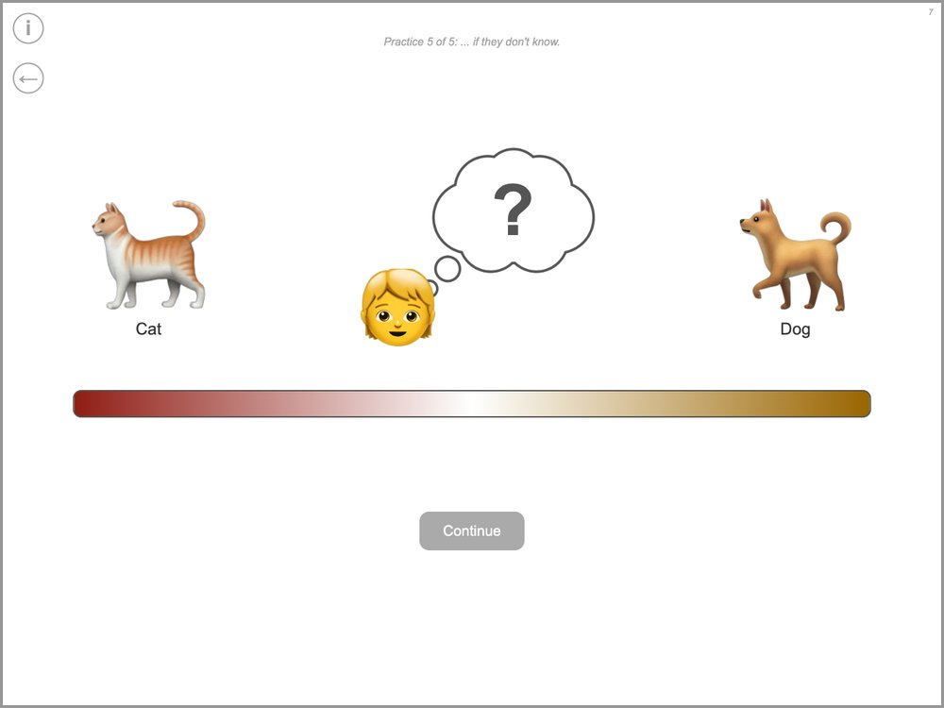 | What to do  Practice 5 of 5: ... if they don't know.  What to say  "Good, and if you didn't know, where would you place your marker?"

Open one box
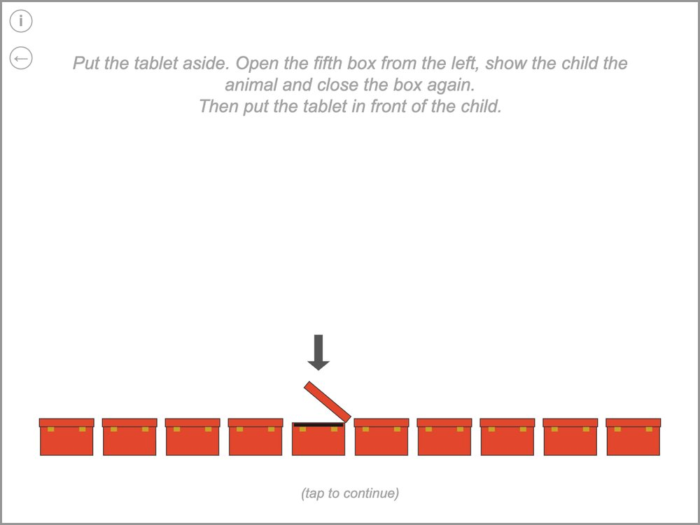 | What to do  Put the tablet aside. Open the fifth box from the left, show the child the animal and close the box again.  Then put the tablet in front of the child.  What to say  "Okay great, I will bring the tablet back in a moment."  "I am going to open one box for you. Let's see what is in it!" [open the box]  "Look, there is a ... in this box!"

First answer: which animal?
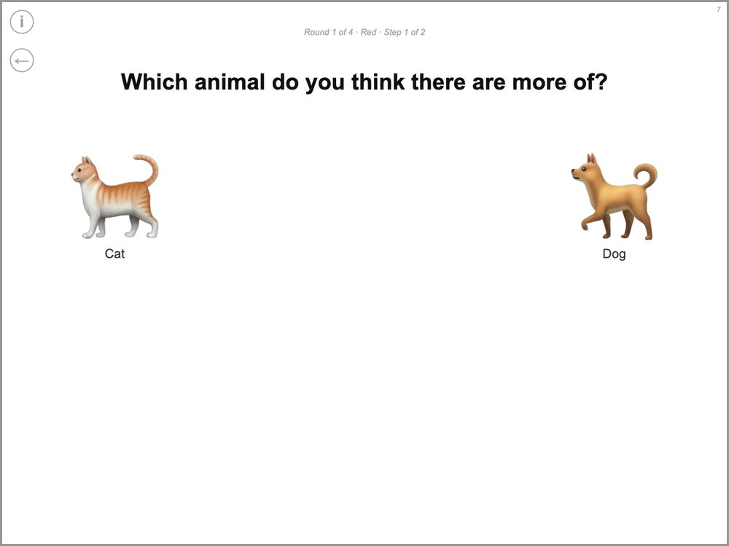 | What to do  Round 1 of 4 · Red · Step 1 of 2  The child taps the animal they think there are more of. Then the scale appears (next picture).  What to say  "Okay, so what do you think? Do you think there are more cats or more dogs in the boxes?"

First answer: how sure?
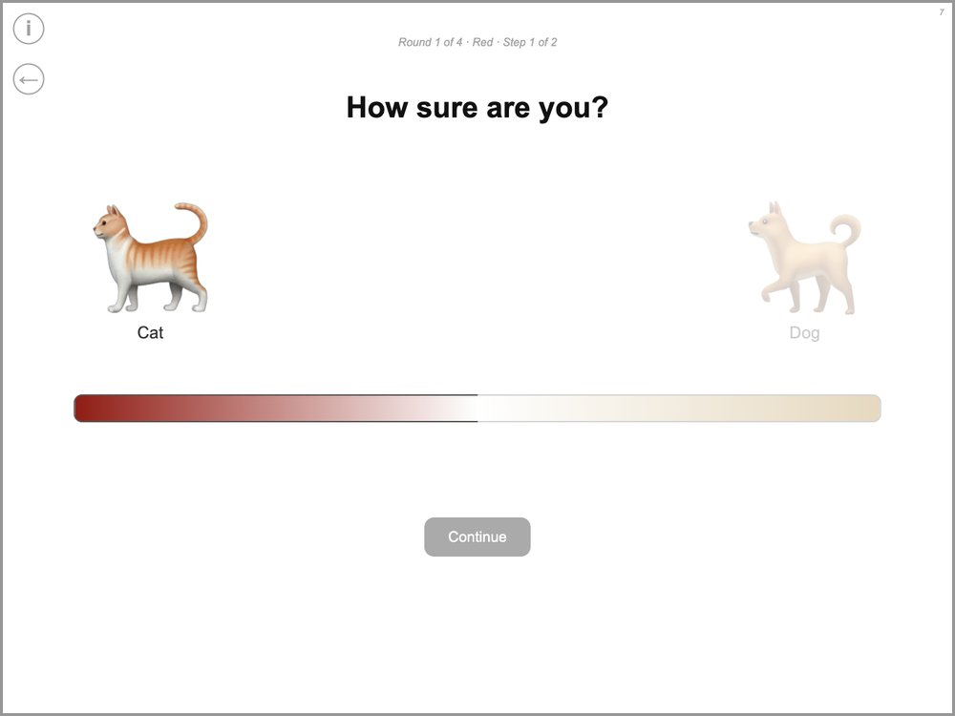 | What to do  Round 1 of 4 · Red · Step 1 of 2  The child places the marker on the scale. Then tap “Continue”.  What to say  "And now you can tell me how sure you are that there are more cats. Do you really think there are more cats, do you kind of think there are more cats, or do you not really know?" [point to each part of the scale]  If the child doesn't move the marker: "So where do you want to place your marker?"

Before the video
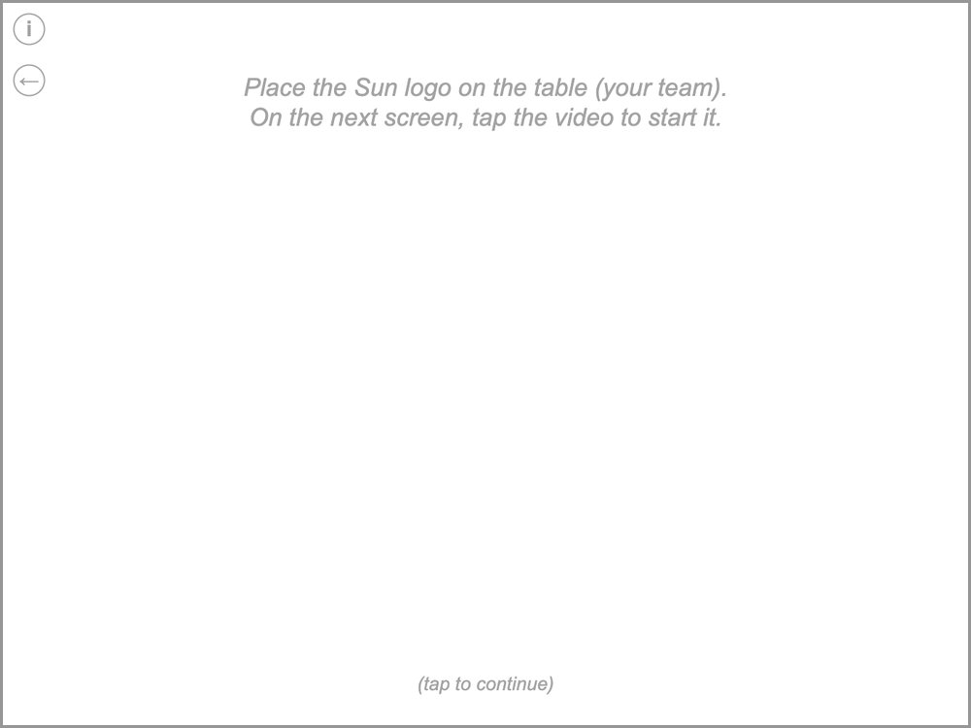 | What to do  Place the Sun logo on the table (your team).  On the next screen, tap the video to start it.  What to say  "Earlier, the Moon team and the Sun team played this game with these boxes, and each team opened some of the boxes. Now we are going to watch a video from one of the teams and see what they think: whether they think there are more cats or more dogs."  "Remember, you are part of the Sun team." [place the logo]  "Look, it's your team, the Sun team! And those are the same boxes we have right here." [point to the boxes]  "Let's see what your team thinks."

Video
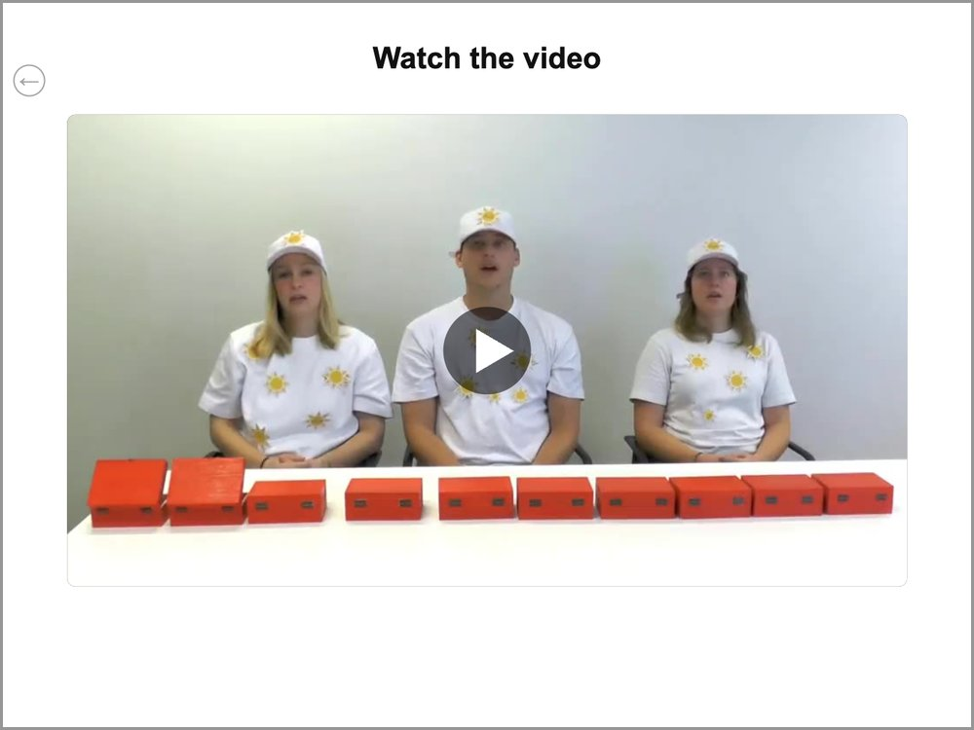 | What to do  Tap the video to start it. When it has finished, tap “Continue”. (“Replay” plays it again.)

Check questions
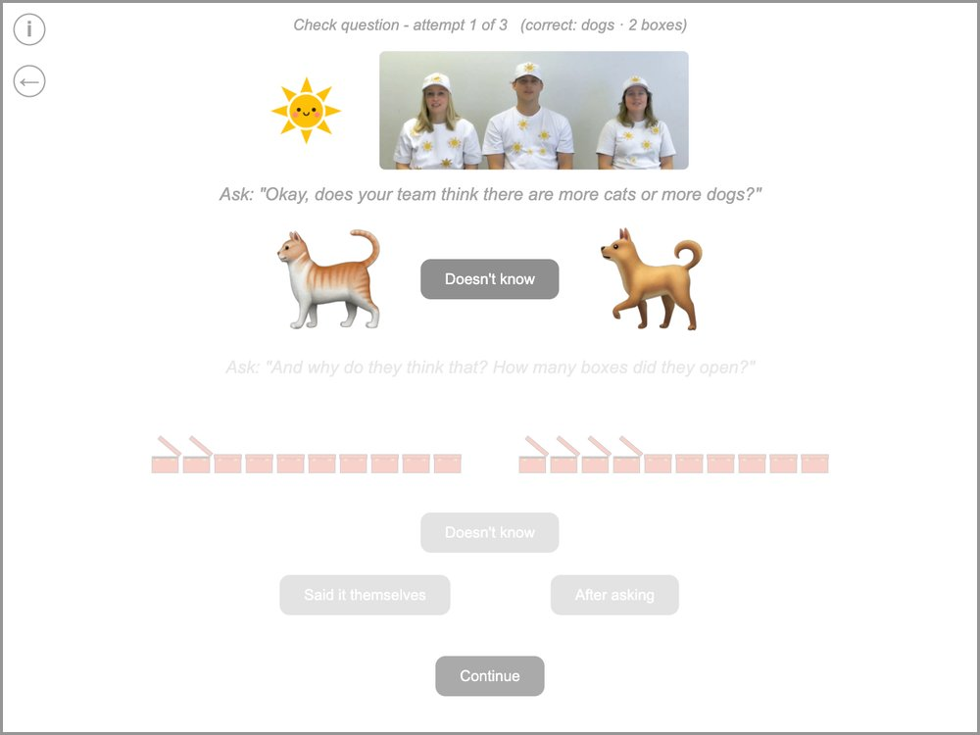 | What to do  Check question - attempt 1 of 3 (correct: dogs · 2 boxes)  Ask: "Okay, does your team think there are more cats or more dogs?"  Ask: "And why do they think that? How many boxes did they open?"  Tap the child’s answers: first the animal, then the boxes (“Doesn't know” if the child doesn’t know). Then tap “Said it themselves” if the child gave the reason on their own, or “After asking” if the child only gave it after you asked further. Then tap “Continue”. The grey line at the top shows the correct answers.  What to say  If right: "That's right, your team thinks there are more dogs."  If right: "That's right, they opened two boxes and they were all dogs."

Only if an answer was wrong
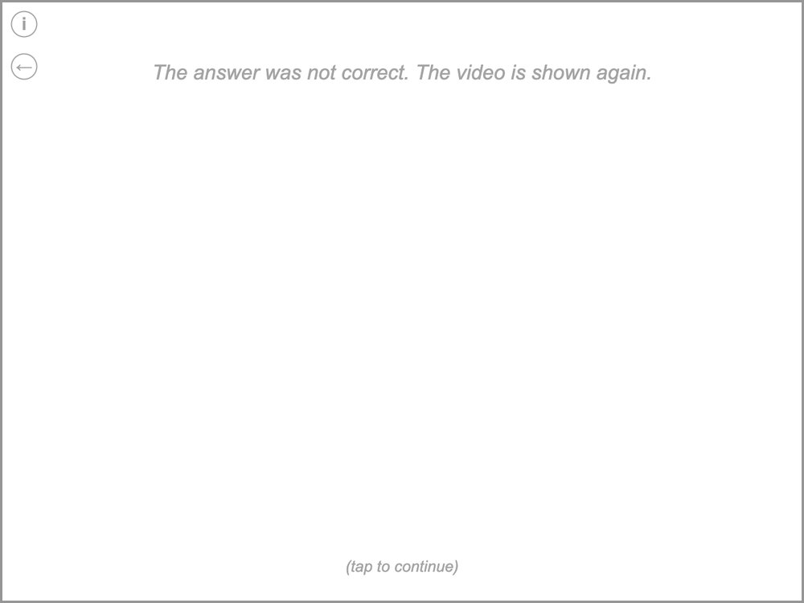 | What to do  The answer was not correct. The video is shown again.  This screen only appears if an answer was wrong. Then the video is shown again and the questions are asked again (at most 3 tries).  What to say  "Hm, let's watch the video one more time!"

Summary
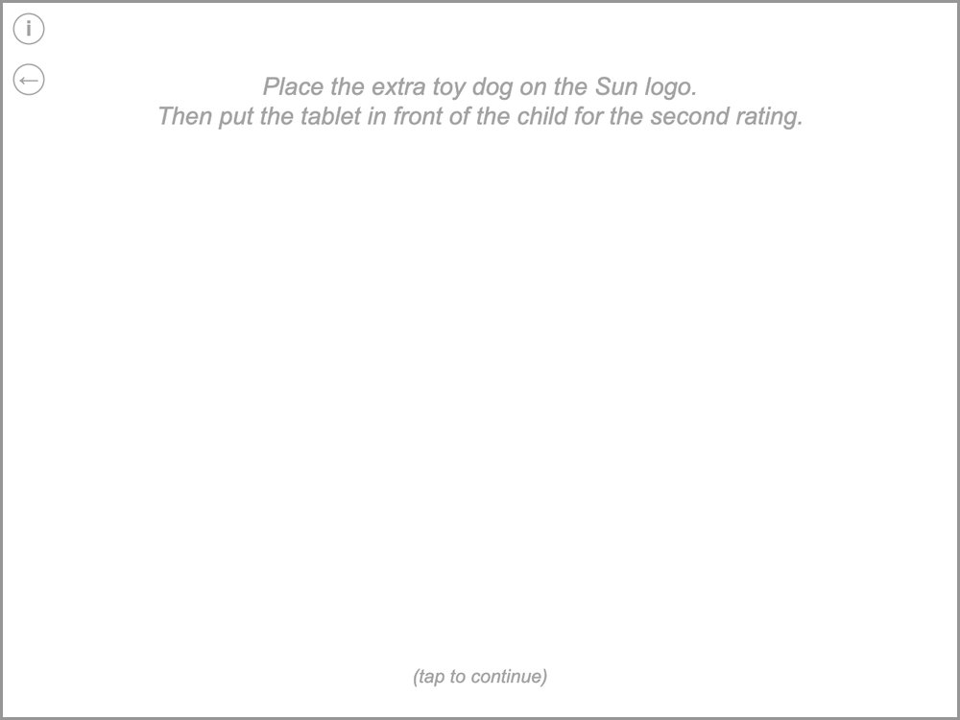 | What to do  Place the extra toy dog on the Sun logo.  Then put the tablet in front of the child for the second rating.  What to say  "So your team thinks there are more dogs, because they opened two boxes and they were all dogs."

Second answer
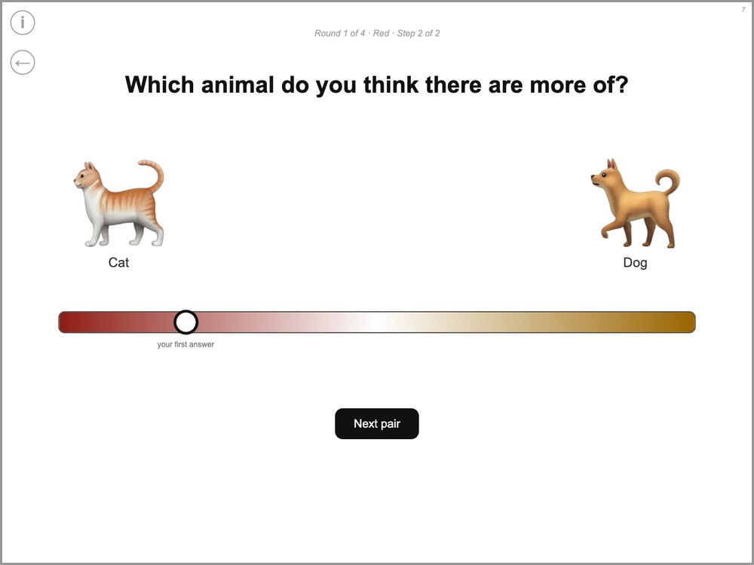 | What to do  Round 1 of 4 · Red · Step 2 of 2  The marker starts at the child’s first answer. The child can move it or leave it there. Then tap “Next pair” (“Finish” in round 4).  What to say  "Earlier you said that you really thought there are more cats in the boxes. So now what do you think? Do you want to move your marker or leave it where it is?"

4. Rounds 2 to 4

Rounds 2, 3 and 4
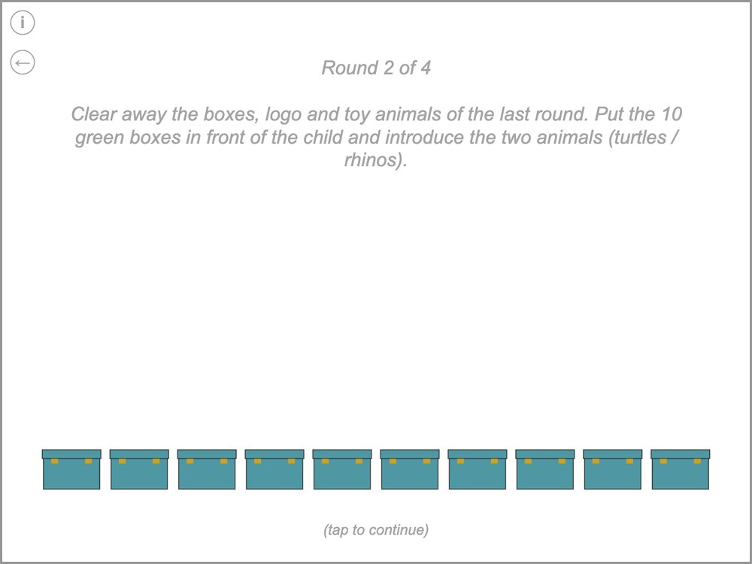 | What to do  Round 2 of 4  Clear away the boxes, logo and toy animals of the last round. Put the 10 green boxes in front of the child and introduce the two animals (turtles / rhinos).  Each new round starts with this screen (new boxes and animals). After it come the same screens as in round 1, from “Open one box” on – without the scale practice.  What to say  "Great job! Now we will play again. These boxes have turtles [hold up the turtle] and rhinos [hold up the rhino] in them." [let the child name both animals]  "Each box has either a turtle or a rhino in it. Your job is to figure out whether there are more turtles or more rhinos. I don't know whether there are more turtles or more rhinos in the boxes."

5. End

Solution
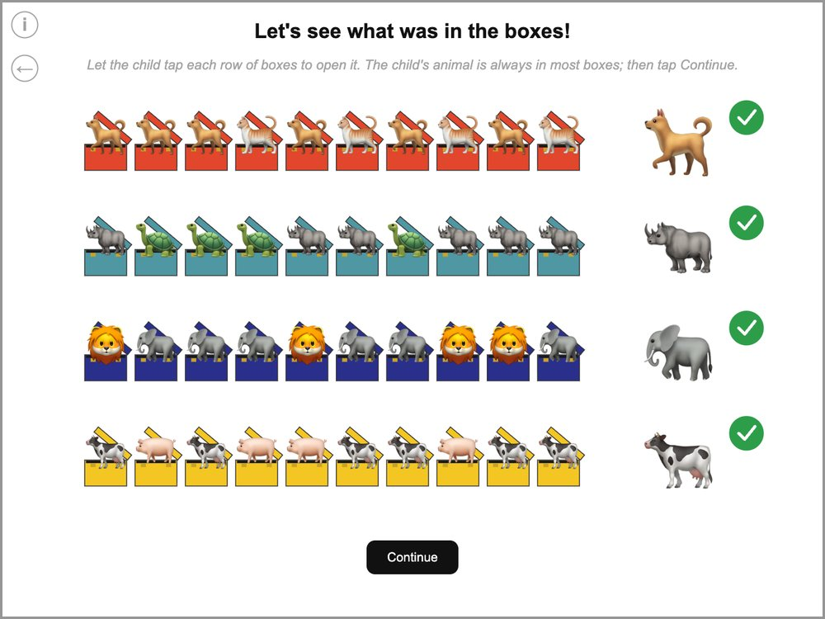 | What to do  Let the child tap each row of boxes to open it. The child's animal is always in most boxes; then tap Continue.  A tick appears next to each row the child has opened.  What to say  "Let's see what was in the boxes! Tap on the boxes." [after each row] "Look, there were more of your animal. You were right!"

End
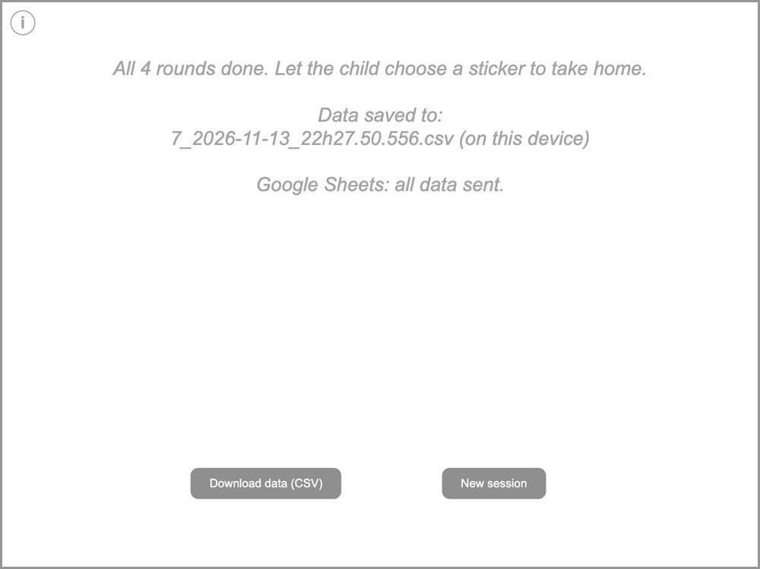 | What to do  All 4 rounds done. Let the child choose a sticker to take home.  Data saved to:  7_2026-11-13_22h27.50.556.csv (on this device)  Google Sheets: all data sent.  Check the line about Google Sheets: it should say that all data were sent. If it does not, tap “Download data (CSV)” as a backup and tell your supervisor. “New session” starts the next child.  What to say  "Awesome! Now we are all done with our game today. You did such a great job! For all of your hard work, you can choose any sticker in here you want to take home!" [show the sticker box]

